Assignment -1

1. **What is SDLC?**

* SDLC stands for Software development life cycle.
* SDLC is structured process use by the software design, developed, test, and deploy software. It’s ensures that the software is created efficiently and meets the required quality standards.

1. **What is software testing?**

* Testing is a process to analysis and identify the difference between existing and require condition meets and evaluate the features of the software item.

1. **What is agile methodology?**

* Agile methodology is an interactive and flexible approach to the software development that focus on collaboration, customer feedback, and small and rapid release.
* The main goal is to respond quickly and deliver working software more rapidly.
* Agile break large software in small manageable unit call sprints or iterations, typically listing 1 to 4 week.

1. **What is SRS**

* A software requirement specification is the complete description of the behaviour of the system to be developed.
* It’s include the set of use cases that describes all the interaction that the user will have with the software.
* It’s contains all the functional information and as well as non-functional information are require to develop the software.

1. **What is oops**

* In software industries we create software in well organised manners is call oops.

1. **Write Basic Concepts of oops?**

* Class
* Object
* Polymorphism
* Inheritances
* Abstractions
* Encapsulation

1. **What is object**

* Object is instance of the class. It’s give the permission to access the functionality of the class.

1. **What is class**

* Class is blueprint for creating objects. It’s define the collection of data member and member functions.

1. **What is encapsulation**

* To collect or wrap the all data in one unit and protecting outside the world.

1. **What is inheritance**

* Create the new class from the existing one. Derive the attribute of same other class.
* Type of inheritance:

1. Single inheritances
2. Multiple inheritance
3. Multilevel inheritance
4. Hierarchical inheritance
5. Hybrid inheritance
6. **What is polymorphism**

* One name multiple form.
* Types: method overriding and method overloading.

1. **What is Abstractions**

* To hide all information and only display essential information.

1. **Write SDLC phases with basic introduction**

* 1. Requirement gathering – to collect the all information to the client and what type of product they want.
* 2. Analysis: - to analysis the information given by the client and how to implement to create the software and also create documents.
* 3. Design: - in the previous stage we create document for the CRS (customer requirements specification), in the design we create design for the software how they look like and how they work like blueprint.
* 4. Development: - In this stage we start the coding to develop the software.
* 5. Testing: - in this stage we check all the Existing product meet the requirement and also check and defect of the project and check the software are 99% bug free.
* 6. Maintenance: - After the deployment for the software in future any requirement, bug any changes, add new features in running application we work on that at long time duration.

1. **Explain Phases of the waterfall model**

* Waterfall model is the classical model of the software development life cycle.
* There is various phase of the Waterfall model describe below:
* Requirement collection:
* This is the first stage of SDLC in this phase we collect the information from the client side and which type of software they need. In this model we collect all info after we move forward to next stage.
* Analysis:
* This stage is to analyse the client requirements convert into documentation format, so we easy to understand the client requirement.
* Design:
* In this stage we convert document into design architecture so we can easy to understand for the client as well as development and testing phase.
* Development:
* This is the main stage of the SDLC, in this stage we can start develop the software and this is take much time compare to other stage. And unit testing also done by the developer.
* Testing:
* In this stage we check the developer created software is meets the client requirement or not and also test the various type of testing on the software. So, the software is 99% bug free and satisfy the client needs.
* Maintenance :
* After testing we deploy the software in client server and they use it. In future if any changes on the software or bug produce the client reach out the developer team and solve this issue for long duration of time period.

1. **Write phases of spiral model**

* Spiral method is other type of model to create the software.
* In the model we collect information and check the project risk and after that we start develop the software and check the client and this is ok we work on the next requirement and continuous repeat this cycle again and again that’s why we call this model is spiral model we continuous change and add the requirement. So we can improve the quality of the software.
* There are various stages describe below:
* Planning phase:

In this phase, we collect information likes its objectives, planning, time duration and future planning.

* Risk management phase:

In this phase, we check the level of risk occur in the project creation like its cost, require man power, software environment, devices etc.

* Development phase:

In this phase, we start develop the software regarding the documentation given by the planning and risk management phase.

* Customer evolution phase:

In this phase, client check the software is as per his requirement or not if it’s satisfied the requirement, we move forward to the next requirement, else we resolve the requirement. After this phase we move again the planning phase and repeat again and again until the software develop completely.

1. **Write agile manifesto principles**

* Customer satisfaction
* Easy to change
* Frequent delivery
* Working software
* Face-to-face conversation
* Simplicity
* Self-organised team
* Collaboration
* Motivated individuals

1. **Explain working methodology of agile model and also write pros and cons.**

* Agile methodology is the interactive and flexible approach for software development that focus on collaboration, customer requirements and easy and rapid release.
* We can divide software project in small modules its call iteration or sprint.
* And each sprint time duration is one to four week.
* Pros:

1. Use for large project.
2. Easy to change.
3. Customer know the status of project
4. Requirement are less so, less work load
5. All team member coordinate easily.
6. Project work on well manner.
7. Solve problem easily and product release on time or before given period of time.
8. Continuous communication with client, product manager and other team member.

* Cons:

1. Good Team co-ordination.
2. Proper communication.
3. Good knowledge about agile-scrum methodology
4. Proper understanding on the requirement.
5. Continuous product updating require.
6. 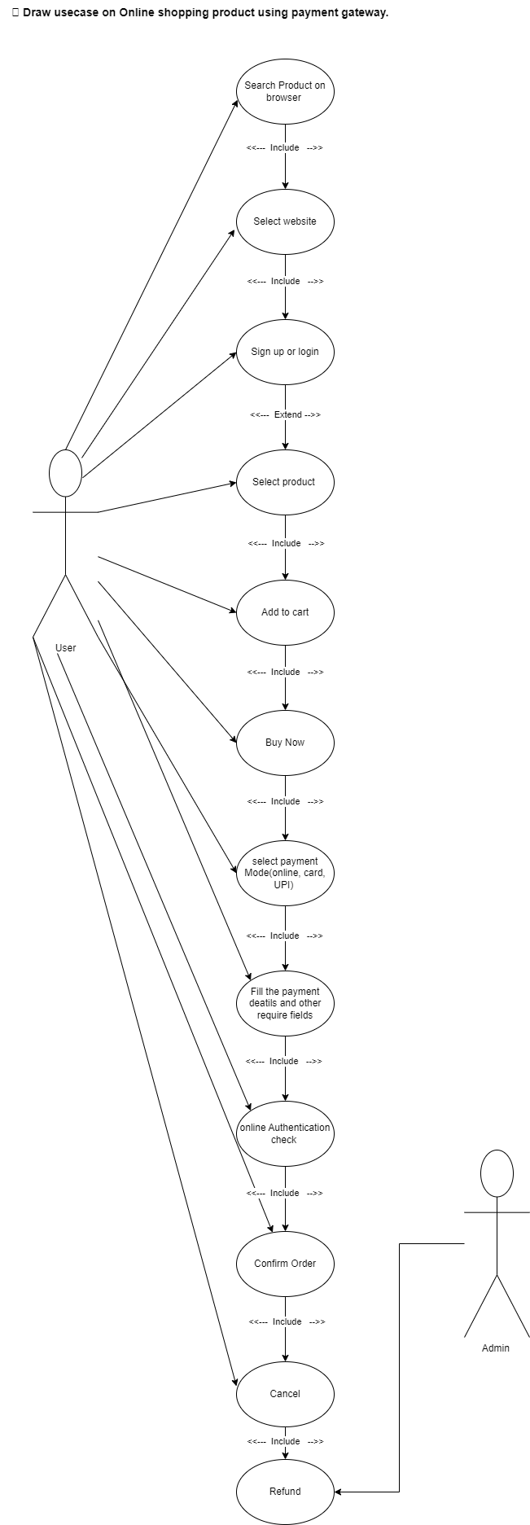**Draw usecase on Online shopping product using payment gateway.**
7. 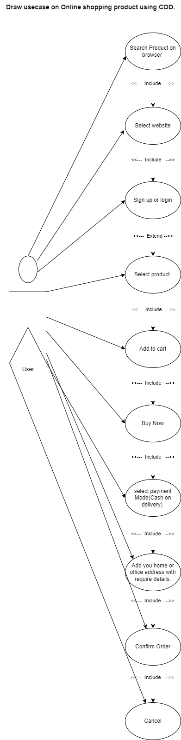**Draw usecase on Online shopping product using COD.**
8. 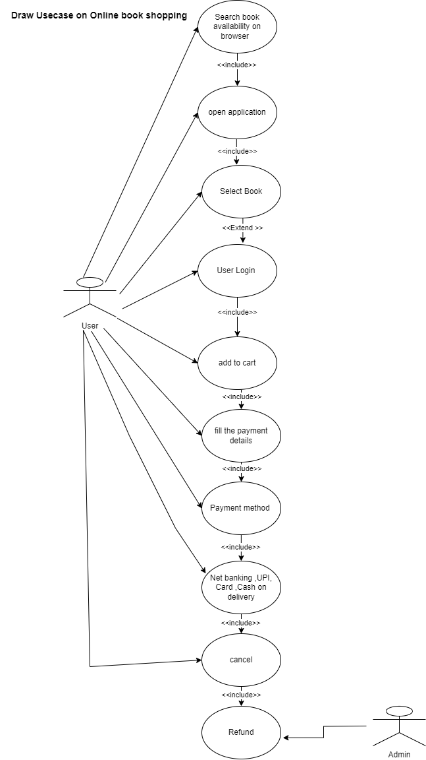**Draw Usecase on Online book shopping**
9. ** Draw Usecase on online bill payment system (paytm)**